Keats Grove Surgery

  - Practice Information Leaflet
Keats Grove Surgery
17 Keats Grove
The Scotlands
Wolverhampton
WV10 8LY
Tel: 01902 731907
www.keatsgrovesurgery.co.uk

The Partners
Dr Martin Kehler (male)
State Exam, Free University – Berlin 1993 MRCGP

Dr Samia Naz (female)
MB, BS – Pakistan 1991 & MRCGP

Dr Thom Dunn (male)
MB ChB 2011 – University of Manchester

Nursing Staff

Practice Nurse: Mrs Sian Westley
RGN, OND (Hons), NARTC Diploma, CHD Cert

Practice Nurse: Mrs Gillian Smith

Healthcare Assistant: Mrs Kerry Hughes
Level 3 Diploma(Open University Awarding Body)

Practice Pharmacist

Mrs Helen Adams
Bsc (Hons) 2.1 Pharmacy Leicester Polytechnic

Management & Administration Team

Practice Manager: Mrs Tracy Sutcliffe

Deputy Practice Manager: Mrs Kim Robinson

Reception Team: Mrs Janet Platt

Mrs Lorraine Jervis

Mrs Lynn Roberts

Mrs Debbie Collins

Mrs Michelle Green

Miss Grace Holder

Administration Team: Mrs Catherine Humphries

Mr Jordan Buckingham

Secretary: Mrs Ginette Green

Overview
The practice is based in a single storey, purpose-built premises with a large car park for both staff and patients. You can find us on the map below:
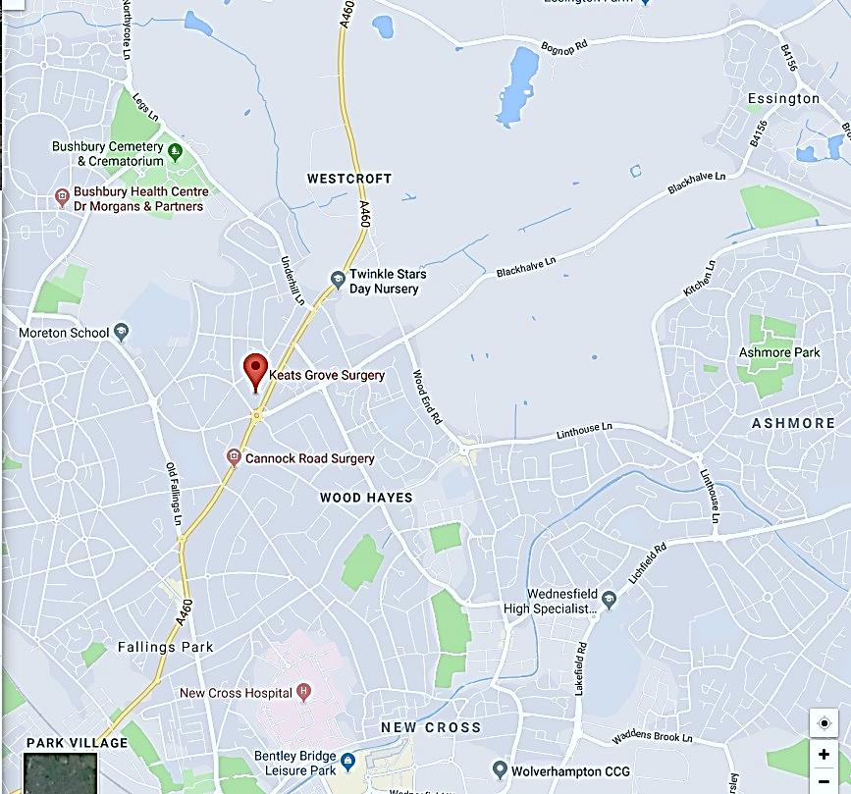
The practice has suitable access for all patients, including access for wheelchair users and pushchairs. Adjacent to the waiting room there are patient toilets, with a separate toilet for disabled patients.

Within the car park there are three designated spaces for disabled parking.

The waiting room offers a range of literature for all patient groups as well as an area for children. A portable induction loop is available at reception for use by patients; please ask a receptionist for further information.

How to Register
We are pleased to accept all patients within the local area. Please bring with you proof of identify and address and ensure you allow sufficient time to complete the registration process.

We will register you with a GP, and you do have a right to request to see a GP of your choice. All patients aged over 75 years will have a named GP. You can find out who your named GP is by asking at reception; this information is also shown on your repeat prescription form.

You can pre-register online, and further information can be found at: www.keatsgrovesurgery.co.uk

Once you are registered with us, you will be able to book appointments online and order repeat prescriptions. For the online service, you will need to bring in a photo ID along with proof of residence. You will then be signed up to the service and given personal login and password information.Full details are available online: www.keatsgrovesurgery.co.uk or by phoning or speaking to a member of the reception or administrative teams.

If you change address, telephone number or change your name, please ensure you contact the practice as soon as possible; this will enable us to update your records. For a change of name, the practice will need to see proof of this, i.e. a Marriage Certificate or Deed Poll.

If you have any questions about the registration process, please speak to a member of staff who will be able to help you.

Hours of Business
Monday | Tuesday | Wednesday | Thursday | Friday
8.00am-6.30pm | 8.00am-6.30pm | 8.00am-6.30pm | 8.00am – 1.00pm | 8.00am-6.30pm
Access Hours |  | Access Hours |  | Access Hours
6.30pm-8.00pm |  | 6.30pm-8.00pm |  | 6.30pm-8.00pm

We operate a same day appointment system for emergencies and immediate and necessary treatment (mornings only). Patients can call the surgery or attend in person. The receptionist will put your name on a GP list for that morning and you will be given a time to come back or you can wait if you prefer. This is a first come first serve basis, therefore, when the appointments for that morning are gone, they are gone.

GP appointments are available between the following hours: 08:00 – 11:30 and 3.10pm – 5.30pm.
An appointment with a GP is ten minutes. Should you have complex or multiple health concerns, please ask the reception staff to arrange a double appointment for you; this will help us to adhere to our appointment schedule and avoid undue delays to other patients.

Appointments with the nursing team are available between 8:00am – 6.00pm, Monday to Friday but days and times differ due to the days that the nursing staff works.

To book an appointment, please call the reception team. In order to allocate you the most appropriate clinical resource, the receptionist will ask you about the nature of your appointment.

Home Visits
Home visits are at the discretion of the GPs and are usually for those patients who are housebound or have significant health issues. Should you require a home visit, please call before 12noon. A clinician may telephone you to discuss your request to ensure that we prioritise the most urgent.

Our Services
Along with the routine appointments, the practice offers the following services:

Family Planning – All of our GPs and the Practice Nurse offer a full range of family planning services.

Immunisations – The nursing team are responsible for the administration of both adult and child immunisations. The practice nurse has set baby vaccination clinics, which are held on Thursday mornings. If you are unable to attend these clinics, please enquire at reception and book an alternative appointment.

Travel Immunisations – The nursing team are able to offer a range of advice regarding travelling abroad and the required vaccinations / medications. Please book an appointment with the nurse to discuss your requirements or speak to your travel agent.

Minor Operations – Simple minor surgery such as joint injections, etc. can be performed by your GP. Please discuss your requirements with your GP who will then inform you if this procedure can be carried out at the surgery or if a referral will need to be made for you to attend elsewhere.

Cervical Smear Testing – This is carried out every three years for women aged 25 – 65, and the tests are undertaken by the nursing team. You will be informed via letter when you are due a test; this is a preventative test, aimed at stopping cancer before it starts.

Well-Man & Well-Women Checks – Nurse-led, these checks are aimed at encouraging a healthy lifestyle for our male and female population aged over 45 years, whilst also encouraging patients to regularly carry out self-examinations. Speak to a member of the nursing team for more information.

Chronic Disease Management – We hold a range of clinics to help our patients manage the following:

Asthma Heart disease Hypertension
Kidney disease Diabetes

We also offer the following services:

Antenatal clinic
Baby clinic
Post-natal checks
Smoking cessation

From time to time, other services may be available such as raising awareness of a particular disease or condition. We will advertise this information on our website and within the practice.

Out of Hours
When the practice is closed, patients are advised to contact the NHS 111 service for all non-life-threatening cases. The 111 operative will advise you accordingly.

In an emergency, dial 999 and ask for the ambulance service. Chest pain and shortness of breath are classed as emergencies.

Ourselves, along with six other surgeries, have combined to provide access appointments from 6.30pm – 8.00pm and during the daytime on weekends. These appointments are available on the day and can be booked directly with each practice or the patient can contact the surgery themselves. Each surgery provides cover on their own set days – please see our website for further information.

Within this area, the local Urgent Care Centre is located within New Cross Hospital. GPs are available and provide an initial triage service, should you feel you need to be seen urgently or out of hours.

Prescriptions
Repeat prescriptions can be ordered in the following ways:

- In person – By ticking the required medications on your prescription and placing it in the dedicated box, located in our reception area.
- Online – Please log in and order via our website
- Chemist – Certain chemists offer an ordering service on behalf of the patient. Please speak to your chemist for further information.

Please allow 48 hours (excluding weekends and bank holidays) after ordering repeat prescriptions before collection.

Should you run out of your medication when the surgery is closed, visit your local pharmacy who may be able to give you an emergency supply.

Urgent requests for medication should be made by speaking to a member of the reception team.

Test Results

You can either call in person or telephone after 2.00pm for your test results. It can take up to five full working days for any Blood test to come back to us and 2 days for Urine samples. X-rays and scans take a lot longer as they have to be viewed and reported on at the hospital before they are sent to us.

Training
We are a training practice; therefore, on occasions we will have GP Registrars, student nurses, pharmacy technicians and other allied healthcare professionals working on-site. You will be advised if this is the case and asked if you are happy for them to be present while you are being seen.
It is our aspiration as a training practice, to see qualified doctors training to become GPs present in the practice for prolonged periods of time. We will communicate this to our patients when the time comes.

Complaints & Comments
We strive to offer an excellent service to our patients but do acknowledge that sometimes things can go wrong. If you are concerned about the service you have received or want to make a complaint, please speak to a member of the team. The complaints manager is the Practice Manager, Mrs Tracy Sutcliffe, who will talk to you about the complaint procedure.

You will be given information about the complaint process and how we respond to and manage complaints. Our aim is to resolve all complaints in a timely manner and we will aim for local resolution each time. If this is not possible, you will be advised of other ways of dealing with your complaint.

Equally, if we do something well, we would very much appreciate your feedback. Comments cards are available in reception and are discussed at practice meetings.

Patient Responsibilities
Our receptionists are here to help and will always try to accommodate your requests and give you an appointment with your named GP or with a clinician you have requested. However, this may not always be possible, but the team will do their utmost to assist you.

We request that you arrive promptly before your appointment, ideally five minutes early. If you are unable to keep your appointment, please telephone us as soon as possible. Cancelling will enable us to offer your appointment to another patient who needs to be seen.

Appointments cancelled with less than 24 hours’ notice constitute as a ‘Did Not Attend’ (DNA) and will be recorded in your health record. Three DNAs within a twelve-month period will be discussed with the management team and it may result in your being asked to register at another practice.

Zero Tolerance
This practice operates a zero-tolerance policy, and the safety of staff is paramount at all times. Our staff have the right to care for others without the fear of being attacked, physically or verbally.

We will not tolerate abuse towards our staff under any circumstances.

Abusive patients will be asked to leave the practice and may be removed from the practice list. We will have no hesitation in calling the police if any patient acts in an abusive manner and is deemed to be a threat to staff and/or patients.

A good doctor-patient relationship is fundamental to excellent patient care. The removal of a patient from the practice list is not commonplace and is a measure that is taken as a last resort.

Personal Health Information
Your information is held on our secure system; we can only disclose this information to a third party with your consent. All information is covered by the Data Protection Act (2018) and the General Data Protection Regulation (GDPR).

You are able to access certain parts of your health record online; please ask at reception for further information. You can request a copy of your medical records using a Subject Access Request form.
The national data opt-out programme will afford patients the opportunity to make an informed choice about whether they wish their confidential patient information to be used just for their individual care and treatment or also used for research and planning purposes. Patients who wish to opt out of data collection will be able to set their national data opt-out choice online. An alternative provision will be made for those patients who are unable to or do not want to use the online system.

Patient Participation Group
We have an active Patient Participation Group (PPG), ensuring that our patients are involved in decisions about the services provided by the practice and Wolverhampton CCG (Clinical Commissioning Group).

For further information about our PPG please contact the surgery.
We want to proactively engage with our patients and at all times maintain an effective working relationship between the practice and our patients.

Clinical Commissioning Group
The local Clinical Commissioning Group (CCG) for this area is:
Wolverhampton Clinical Commissioning Group
Technology Centre
Wolverhampton Science Park
Glaisher Drive
Wolverhampton
WV10 9RU
Tel: 01902 444878
Email: wolccg.wccg@nhs.net
Website: www.wolverhamptonccg.nhs.uk

Further information about local services can be found by visiting the NHS Choices website.

Useful Information
The following telephone numbers may be of use:

- New Cross Hospital – 01902 307999 (switchboard)
- The Gem Centre – 01902 446270
- Wolverhampton City Council – 01902 551155

